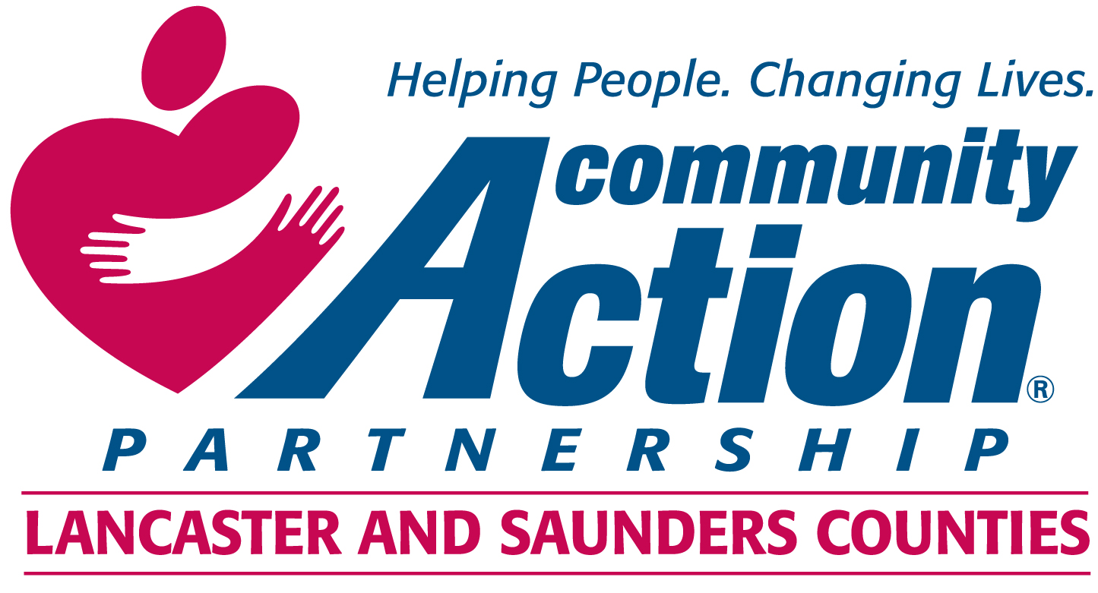

Procedure Guiding Petition for Representation on the Board of Directors

Per federal and state regulation (42U.S.C9908(b)10; State Reg.:2-001.06) eligible entities may petition for adequate representation on the Community Action Board of Directors if a low income individual, community organization, religious organization, or representative of low income individuals feels under-represented on the board.
Entities wishing to petition for representation on the Community Action Board of Directors shall:
- Complete this form and submit to the Executive Director, Community Action, 210 O Street, Lincoln, NE 68508.
- Attached a signed document demonstrating support of at least 40 adult members of the petitioning group. Document shall include name, address, email address (if available) and individual’s signature.
- The Nominating Committee shall consider the petition, may meet with representatives of the petitioning group, and will make a recommendation of approval or disapproval to the Board of Directors within 30 days of receiving the petition.
- The Board of Directors shall take action on the recommendation of the Nominating Committee within 60 days of receipt. If the petition is approved the Board shall make the necessary provisions to revise the composition of the Board to include the petitioning group while also maintaining compliance with funding contracts, agreements and sub awards.

All petitioning groups shall complete the reverse side of this document and attach a petition including information designated in #2. All individuals supporting the petition must be at least 19 years of age, a resident of Lancaster and Saunders Counties, and not currently employed by Community Action or directly related to someone who is employed by Community Action.

Notification of Petition for Representation on the Community Action Board of Directors
Complete and return to CEO, Community Action, 210 O Street, Lincoln, NE 68508.

Description of Petitioning Group:

Name of Primary Contact Person:

Preferred Mailing Address:

Preferred Phone: Email Address:

Describe the believed lack of representation as supported by at least 40 adult individuals signing this petition. (attach petition to this form)

Please confirm that all signing the petition as supporters are:

_____At least 19 years of age.
_____Reside in Lancaster or Saunders County.
_____Are not employed by Community Action or related to a current employee.

____________________________________________ __________________________
Submitted by – Print Name Date

_________________________________________________________________________
Signature

